Question 2 part 4:

 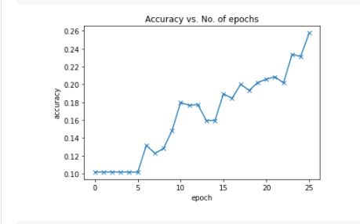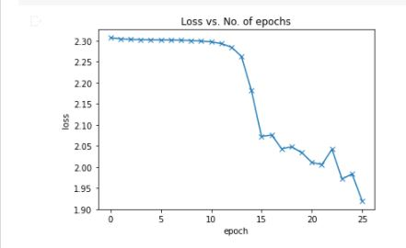

Figure 3 feed forward network with Adam optimizer accuracy = 26

Figure 2 feed forward network with Adam optimizer accuracy curve

Figure feed forward network with Adam optimizer loss curve